PROJECT REPORT
on
Attendance Management System
(CS V Semester Mini project)
2017-18


Submitted to: Submitted by:
Mr. B. P. Dubey Mr. Lokesh Singh
Mr. Manish Chauhan

DEPARTMENT OF COMPUTER SCIENCE AND INFORMATION TECHNOLOGY
GRAPHIC ERA HILL UNVERSITY, DEHRADUN

CERTIFICATE

Certified that Mr. Lokesh Singh (Roll No: 1011681), Mr. Manish Chauhan (Roll No: 1011687) have developed DBMS based project on Attendance Management System for the CS V Semester Mini Project Lab in Graphic Era Hill University, Dehradun under my supervision. The project carried out by Students is their own work as best of my knowledge.

Date: (Mr. B.P. Dubey)
SUPERVISOR
Assistant Professor
Department of CS/IT GEHU, Dehradun

ACKNOWLEDGMENT

We would like to express our gratitude to The Almighty Shiva Baba, the most beneficent and the most Merciful, for completion of project.
We wish to thank our parents for their continuing support and encouragement. We also wish to thank them for providing us with the opportunity to reach this far in our studies.
We would like to thank particularly our Supervisor Mr. B. P. Dubey for his patience, support and encouragement throughout the completion of this project and having faith in us.
We also acknowledge to all teachers specially Shashi Sharma Sir, Mahesh Manchanda Sir and Amit Kumar Gupta Sir who help us in developing the project.
At last but not the least We greatly indebted to all other persons who directly or indirectly helped us during this work.

Mr. Lokesh Singh Mr. Manish Chauhan
(Roll No.- 1011681) (Roll No.- 1011687)

TABLE OF CONTENTS

CHAPTER NO. TITLE PAGE NO.
LIST OF TABLES vi
LIST OF FIGURES vii
LIST OF SYMBOLS, ABBREVIATIONS viii
1. INTRODUCTION 1
1.1 About Project 1
1.2 Java 1
1.2.1 Swings 2
1.2.2 JDBC 2
1.3 DBMS 3
1.3.1 RDBMS 3
1.3.2 SQL 4
1.3.3 E-R Model 4
1.3.4 MySQL 5

2. PROJECT 6
2.1 Requirement Analysis 6
2.2 Software Specification 6
2.3 E-R Diagram 7
2.4 Module 7
2.4.1 Login Page 7
2.4.2 Addition of Students 7
2.4.3 Deletion of Students 8
2.4.4 Addition of Attendance 8
2.4.5 Generation of Record 8
3. SNAPSHOT OF PROJECT 9
3.1 Login 9
3.2 Addition of Students 9
3.3 Deletion of Students 10
3.4 Generation of Record 10
3.5 Addition of Attendance 11

4. CONCLUSION 12
4.1 SUMMARY 12
4.2 FUTURE WORKS 12

APPENDIX: CODE 13
REFERENCE 27

LIST OF TABLES

TABLE Page No.

Table 1.1 Attendance 10
Table 2.1 Student 13
Table 2.2 Teacher 18

LIST OF FIGURES

FIGURE Page No.

Figure 1.1 E-R Diagram 7

LIST OF SYMBOLS, ABBREVIATIONS

DBMS Data Base Management System
RDBMS Relational Data Base Management System
SQL Structure Query Language
E-R Entity Relationship
JDBC Java DataBase Connectivity

CHAPTER 1
INTRODUCTION

  - ABOUT PROJECT
Attendance Management System is a software developed for daily student attendance in schools, colleges and institutes. If facilitates to access the attendance information of a particular student in a particular class. The information is sorted by the operators, which will be provided by the teacher for a particular class. This system will also help in evaluating attendance eligibility criteria of a student.
Purpose: - The purpose of developing attendance management system is to computerized the tradition way of taking attendance. Another purpose for developing this software is to generate the report automatically at the end of the session or in the between of the session.
Scope: - The scope of the project is the system on which the software is installed, i.e. the project is developed as a desktop application, and it will work for a particular institute. But later on the project can be modified to operate it online. Attendance Management System.

1.2 JAVA

Java is a high-level, third generation programming language, like C, FORTRAN, Smalltalk, Perl, and many others. You can use Java to write computer applications that play games, store data or do any of the thousands of other things computer software can do. Compared to other programming languages, Java is most similar to C. However although Java shares much of C's syntax, it is not C. Knowing how to program in C or, better yet, C++, will certainly help you to learn Java more quickly, but you don't need to know C to learn Java. A Java compiler won't compile C code, and most large C programs need to be changed substantially before they can become Java programs. What's most special about Java in relation to other programming languages is that it lets you write special programs called applets that can be downloaded from the Internet and played safely within a web browser. Java language is called as an Object-Oriented Programming language and before beginning for Java, we have to learn the concept of OOPs(Object-Oriented Programming).

1.2.1 SWINGS

Java Swing is a part of Java Foundation Classes (JFC) that is used to create window-based applications. It is built on the top of AWT (Abstract Windowing Toolkit) API and entirely written in java.
Unlike AWT, Java Swing provides platform-independent and lightweight components.
The javax.swing package provides classes for java swing API such as JButton, JTextField, JTextArea, JRadioButton, JCheckbox, JMenu etc.

Swing features
- Light Weight - Swing component are independent of native Operating System's API as Swing API controls are rendered mostly using pure JAVA code instead of underlying operating system calls.
- Rich controls - Swing provides a rich set of advanced controls like Tree, TabbedPane, slider, colorpicker, table controls
- Highly Customizable - Swing controls can be customized in very easy way as visual apperance is independent of internal representation.
- Pluggable look-and-feel- SWING based GUI Application look and feel can be changed at run time based on available values.

1.2.2 JDBC

JDBC stands for Java Database Connectivity, which is a standard Java API for database-independent connectivity between the Java programming language and a wide range of databases.
The JDBC library includes APIs for each of the tasks commonly associated with database usage:
- Making a connection to a database
- Creating SQL or MySQL statements
- Executing that SQL or MySQL queries in the database
- Viewing & Modifying the resulting records

1.3 DBMS
A database is an organized collection of data. A relational database, more restrictively, is a collection of schemas, tables, queries, reports, views, and other elements. Database designers typically organize the data to model aspects of reality in a way that supports processesrequiring information, such as (for example) modelling the availability of rooms in hotels in a way that supports finding a hotel with vacancies.
A database-management system (DBMS) is a computer-software application that interacts with end-users, other applications, and the database itself to capture and analyze data. A general-purpose DBMS allows the definition, creation, querying, update, and administration of databases. Well-known DBMSs include MySQL, PostgreSQL, EnterpriseDB, MongoDB, MariaDB, Microsoft SQL Server, Oracle, Sybase, SAP HANA, MemSQL, SQLite and IBM DB2.
A database is not generally portable across different DBMSs, but different DBMSs can interoperate by using standards such as SQL and ODBC or JDBC to allow a single application to work with more than one DBMS. Computer scientists may classify database-management systems according to the database models that they support; the most popular database systems since the 1980s have all supported the relational model - generally associated with the SQL language. Sometimes a DBMS is loosely referred to as a "database".

1.3.1 RDBMS
A relational database management system (RDBMS) is a database management system (DBMS) that is based on the relational model invented by Edgar F. Codd, of IBM's San Jose Research Laboratory. As of 2017, many of the databases in widespread use are based on the relational database model.
RDBMSs have been a common choice for the storage of information in new databases used for financial records, manufacturing and logistical information, personnel data, and other applications since the 1980s. Relational databases have often replaced legacy hierarchical databases and network databases because they are easier to understand and use. However, relational databases have received unsuccessful challenge attempts by object database management systems in the 1980s and 1990s (which were introduced trying to address the so-called object-relational impedance mismatch between relational databases and object-oriented application programs) and also by XML database management systems in the 1990s. Despite such attempts, RDBMSs keep most of the market share, which has also grown over the years.

1.3.2 SQL
SQL(Structured Query Language) is a domain-specific language used in programming and designed for managing data held in a relational database management system(RDBMS), or for stream processing in a relational data stream management system (RDSMS). In comparison to older read/write APIs like ISAM or VSAM, SQL offers two main advantages: first, it introduced the concept of accessing many records with one single command; and second, it eliminates the need to specify how to reach a record, e.g. with or without an index.
Originally based upon relational algebra and tuple relational calculus, SQL consists of a data definition language, data manipulation language, and data control language. The scope of SQL includes data insert, query, update and delete, schema creation and modification, and data access control. Although SQL is often described as, and to a great extent is, a declarative language (4GL), it also includes procedural elements.
SQL was one of the first commercial languages for Edgar F. Codd's relational model, as described in his influential 1970 paper, "A Relational Model of Data for Large Shared Data Banks". Despite not entirely adhering to the relational model as described by Codd, it became the most widely used database language.
SQL became a standard of the American National Standards Institute (ANSI) in 1986, and of the International Organization for Standardization (ISO) in 1987. Since then, the standard has been revised to include a larger set of features. Despite the existence of such standards, most SQL code is not completely portable among different database systems without adjustments.

1.3.3 E-R MODEL

An entity–relationship model (ER model) describes inter-related things of interest in a specific domain of knowledge. An ER model is composed of entity types (which classify the things of interest) and specifies relationships that can exist between instances of those entity types.
In software engineering an ER model is commonly formed to represent things that a business needs to remember in order to perform business processes. Consequently, the ER model becomes an abstract data model that defines a data or information structure that can be implemented in a database, typically a relational database.
Entity–relationship modeling was developed for database design by Peter Chen and published in a 1976 paper. However, variants of the idea existed previously. Some ER modelers show super and subtype entities connected by generalization-specialization relationships, and an ER model can be used also in the specification of domain-specific ontologies.

1.3.4 MYSQL

MySQL is an open-source relational database management system(RDBMS). Its name is a combination of "My", the name of co-founder Michael Widenius's daughter, and "SQL", the abbreviation for Structured Query Language. The MySQL development project has made its source code available under the terms of the GNU General Public License, as well as under a variety of proprietary agreements. MySQL was owned and sponsored by a single for-profit firm, the Swedish company MySQL AB, now owned by Oracle Corporation. For proprietary use, several paid editions are available, and offer additional functionality.
MySQL is a central component of the LAMP open-source web application software stack (and other "AMP" stacks). LAMP is an acronym for "Linux, Apache, MySQL, Perl/PHP/Python". Applications that use the MySQL database include: TYPO3, MODx, Joomla, WordPress, phpBB, MyBB, and Drupal. MySQL is also used in many high-profile, large-scale websites, including Google (though not for searches), Facebook, Youtube.

CHAPTER 2
PROJECT

2.1 REQUIREMENT ANALYSIS
Technology Used:-
Language: - Java Swings
Backend: - SQL System

Minimum Requirement:-
RAM: - 256 MB
Hard Disk: - 40 GB
Processor: - Intel Pentium 4
Operating System: - Windows XP Service Pack2

2.3 E-R DIAGRAM
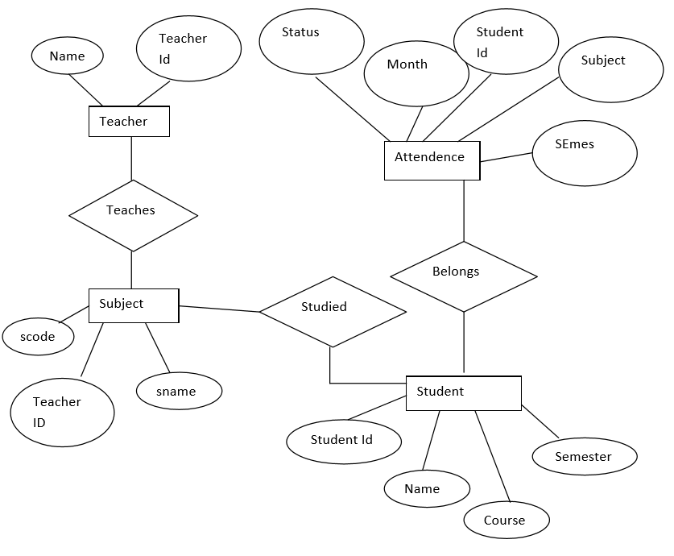
2.4 MODULE
2.4.1 LOGIN
This is the welcome window for both teacher and student. In this the teacher will enter its name as username and his/her password to login into the system.
The Student will use their name for username and registration number for password to login.

2.4.1 ADDITION OF STUDENTS
This module can only be accessed by the teacher, in this the teacher can add students to the database.

2.4.2 DELETION OF STUDENTS
This module can only be accessed by the teacher, in this the teacher can delete students from the database.

2.4.3 ADDITION OF ATTENDANCE
This module can only be accessed by the teacher, in this the teacher can add attendance of each student to the database.

2.4.4 GENERATE RECORD
This module can be accessed by both students and teacher. The Teacher can generate the record of all the students he/she teach. Students can only generate the record of his attendance subject wise.

CHAPTER 3
SNAPSHOT OF PROJECT

3.1 LOGIN PAGE
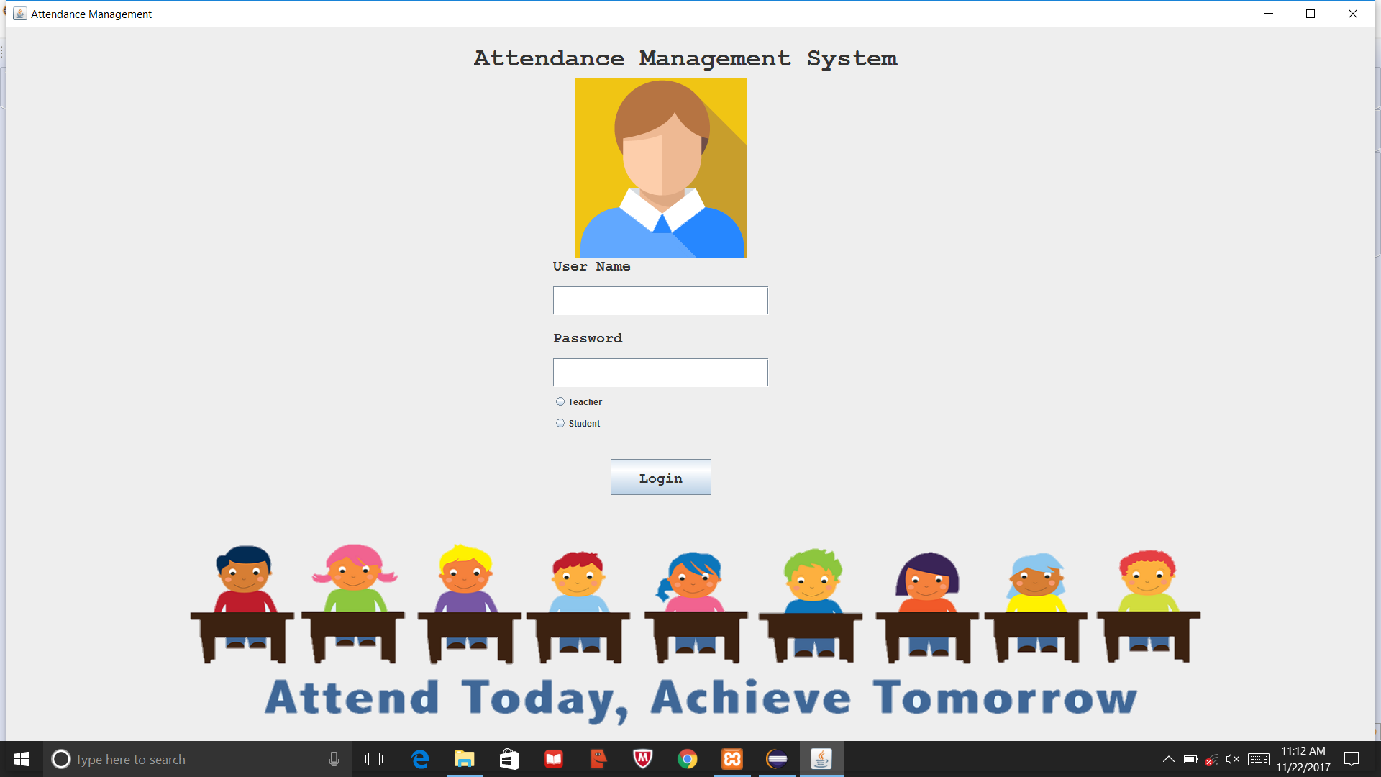
3.2 ADDITION OF STUDENTS
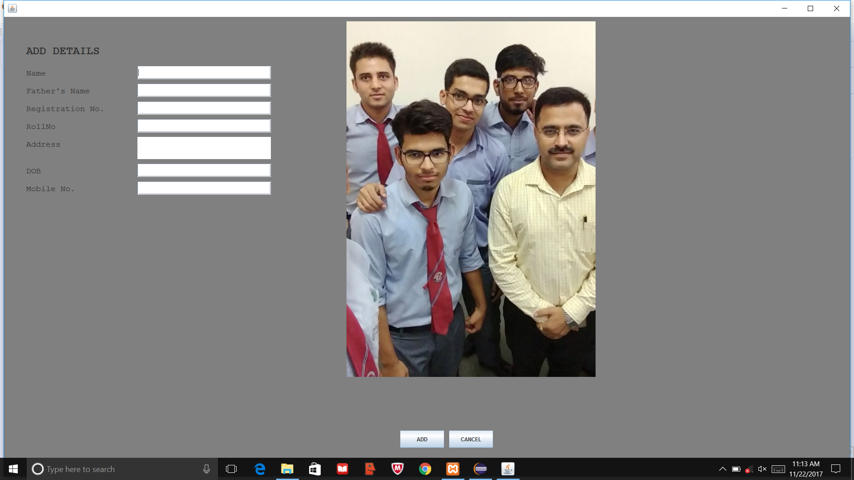
3.3 DELETION OF STUDENTS
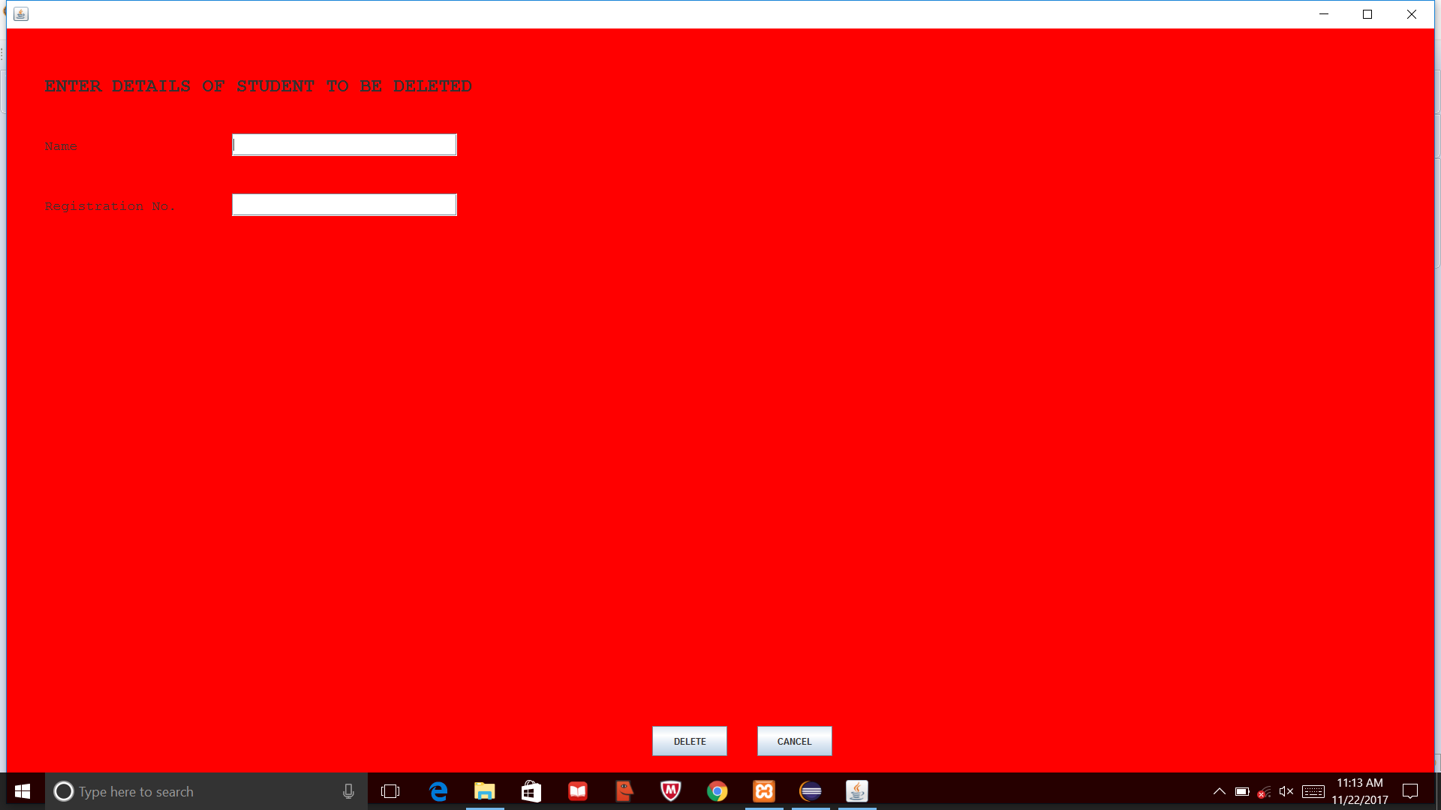

3.4 GENERATE RECORD
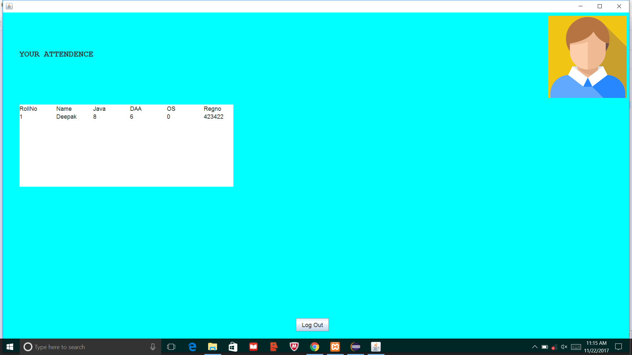

3.5 ADDITION OF ATTENDANCE
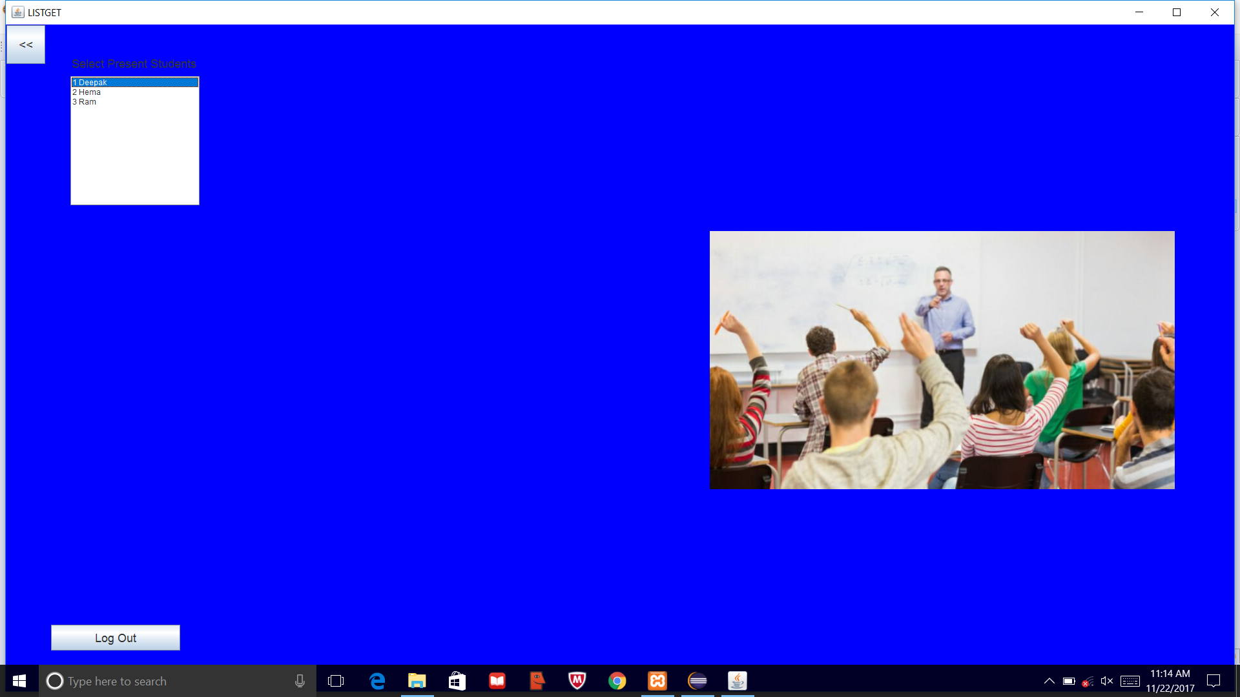

CHAPTER 4
CONCLUSION
4.1 Summary

The Attendance Management System is developed using JAVA Swings and JDBC fully meets the objectives of the system which it has been developed. The system has reached a steady state where all bugs have been eliminated. The system is operated at a high level of efficiency and all the teachers and user associated with the system understands its advantage. The system solves the problem. It was intended to solve as requirement specification.

4.2 Future Works

The proposed Attendance System can be used in the future because of following characteristics:
- User Friendly: - The proposed system is user friendly because the retrieval and storing of data is fast and data is maintained efficiently. Moreover the graphical user interface is provided in the proposed system, which provides user to deal with the system very easily.
- Reports are easily generated: - Reports can be easily generated in the proposed system so user can generate the report as per the requirement (monthly) or in the middle of the session. User can give the notice to the students so he/she become regular.
- Very less paper work: - The proposed system requires very less paper work. All the data is feted into the computer immediately and reports can be generated through computers. Moreover work becomes very easy because there is no need to keep data on papers.

APPENDIX
Code
LogIn.java

package attendencemanagement;
import java.awt.*;
import javax.swing.*;
import javax.tools.Tool;
import java.awt.event.*;
import java.sql.*;

class LogIn extends JFrame implements ActionListener,ItemListener{
Container c;
Dimension screensize=Toolkit.getDefaultToolkit().getScreenSize();
Boolean s=false,t=false;
JLabel uLabel=new JLabel("User Name");
JLabel pLabel =new JLabel("Password");
JLabel head=new JLabel("Attendance Management System");
JTextField uname=new JTextField();
JPasswordField pass=new JPasswordField();
JRadioButton stu,te;
ButtonGroup b=new ButtonGroup();
JButton loginbtn=new JButton("Login");
JLabel b1,b2;
static int noc=1;
LogIn()
{

c=this.getContentPane();
c.setLayout(null);
ImageIcon i = new ImageIcon("F:\\JAVA CSB\\attendencemanagement\\src\\attendencemanagement\\login-icon.png");

b1=new JLabel(i);
b1.setBounds((int)(screensize.getWidth()/2)-175,70,250,250);

ImageIcon i1 = new ImageIcon("F:\\JAVA CSB\\attendencemanagement\\src\\attendencemanagement\\attendance-banner.png");
b2=new JLabel(i1);
b2.setBounds((int)(screensize.getWidth()/2)-778,(int)screensize.getHeight()-400,1549,400);
c.add(b2);

head.setBounds(650,20,1000,40);
uLabel.setBounds((int)(screensize.getWidth()/2)-200,310,200,40);
uname.setBounds((int)(screensize.getWidth()/2)-200,360,300,40);
pLabel.setBounds((int)(screensize.getWidth()/2)-200,410,200,40);
//c.setBounds((int)(screensize.getWidth()/2)-200,200,200,40);
pass.setBounds((int)(screensize.getWidth()/2)-200,460,300,40);
loginbtn.setBounds((int)(screensize.getWidth()/2)-120,600,140,50);
loginbtn.addActionListener(this);

Font f=new Font("Monospaced", Font.BOLD,20);
Font f1=new Font("Monospaced", Font.BOLD,35);
uLabel.setFont(f);
pLabel.setFont(f);
head.setFont(f1);
uname.setFont(f);
pass.setFont(f);

loginbtn.setFont(f);

stu=new JRadioButton("Student");
te=new JRadioButton("Teacher");
stu.setBounds((int)(screensize.getWidth()/2)-200,530,80,40);
te.setBounds((int)(screensize.getWidth()/2)-200,500,80,40);
b.add(stu);
b.add(te);
stu.addItemListener(this);
te.addItemListener(this);

c.add(b1);
c.add(uLabel);
c.add(pLabel);
c.add(head);
c.add(uname);
c.add(pass);
c.add(loginbtn);
c.add(stu);
c.add(te);

setVisible(true);
setTitle("Attendance Management");
setDefaultCloseOperation(JFrame.EXIT_ON_CLOSE);

setBounds(0,0,(int)screensize.getWidth(),(int)screensize.getHeight());
}

public void actionPerformed(ActionEvent e){
if(e.getSource()==loginbtn)
{
String username=uname.getText();
String password=pass.getText();
if(s==true)
{
try
{
boolean f=true;
Class.forName("com.mysql.jdbc.Driver");
Connection con=DriverManager.getConnection("jdbc:mysql://localhost:3306/amdb","root","");
Statement stmt=con.createStatement();
ResultSet rs=stmt.executeQuery("select * from teacher");
while(rs.next())
{

if(username.equals(rs.getString("name")) && password.equals(rs.getString("password")))
{
noc=rs.getInt("noofclass");
new TeacherMenu(rs.getInt("Sno"));
f=false;
dispose();
}
}
if(f)
JOptionPane.showMessageDialog(null,"Invalid UserName or Password");// msg=new JOptionPane()
con.close();
}
catch(Exception e2)
{
System.out.println(e2);
}
}
else if(t==true)
{
try
{
boolean f=true;
Class.forName("com.mysql.jdbc.Driver");
Connection con=DriverManager.getConnection("jdbc:mysql://localhost:3306/amdb","root","");
Statement stmt=con.createStatement();
ResultSet rs=stmt.executeQuery("select * from student");
while(rs.next())
{

if(username.equals(rs.getString("name")) && password.equals(rs.getInt("regno")+""))
{
new StudentMenu(rs.getInt("regno"));
f=false;
dispose();
}
}
if(f)
JOptionPane.showMessageDialog(null,"Invalid UserName or Password");// msg=new JOptionPane()
con.close();
}
catch(Exception e2)
{
System.out.println(e2);
}
}
else
{
JOptionPane.showMessageDialog(null,"Select Catogary");
}

}

}

@Override
public void itemStateChanged(ItemEvent e) {
// TODO Auto-generated method stub
if(te.isSelected()==true)
s=true;
else
t=true;
}
public static void main(String a[])
{
new LogIn();
}

}

TeacherMenu.java

package attendencemanagement;
import java.awt.*;
import java.awt.event.*;
import javax.swing.*;

public class TeacherMenu extends JFrame implements ActionListener{
JButton addst,delst,genrec,addatt,lgout;
Dimension screensize=Toolkit.getDefaultToolkit().getScreenSize();
int x;
Container c1;
TeacherMenu(int n)
{
x=n;
c1=getContentPane();
c1.setLayout(null);
c1.setBackground(Color.yellow);
String s;
ImageIcon i = new ImageIcon("F:\\JAVA CSB\\attendencemanagement\\src\\attendencemanagement\\"+x+".jpeg");
JLabel b1=new JLabel(i);
b1.setBounds(1370,50,400,450);
c1.add(b1);
JLabel l=new JLabel("Menu");
addst=new JButton("Add Student");
delst=new JButton("Delete Student");
genrec=new JButton("Generate Record");
addatt=new JButton("Add Today's Attendance");
l.setBounds(50,50,100,50);
addst.setBounds(50,100,300,50);
addst.addActionListener(this);
delst.setBounds(50,160,300,50);
delst.addActionListener(this);
genrec.setBounds(50,220,300,50);
genrec.addActionListener(this);
addatt.setBounds(50,280,300,50);
addatt.addActionListener(this);
Font f=new Font("Monospaced", Font.PLAIN,18);
Font f1=new Font("Monospaced", Font.BOLD,25);

l.setFont(f1);
addst.setFont(f);
delst.setFont(f);
genrec.setFont(f);
addatt.setFont(f);
c1.add(addst);
c1.add(l);
c1.add(delst);
c1.add(addatt);
c1.add(genrec);

setDefaultCloseOperation(JFrame.EXIT_ON_CLOSE);
setBounds(0,0,(int)screensize.getWidth(),(int)screensize.getHeight());

setLayout(null);
setVisible(true);
lgout=new JButton("Log Out");
lgout.setBounds((int)(screensize.getWidth()/2)-70,(int)(screensize.getHeight())-250,200,40);
lgout.addActionListener(this);
lgout.setFont(f);
c1.add(lgout);
}
public static void main(String a[])
{
new TeacherMenu(0);
}
@Override
public void actionPerformed(ActionEvent a) {
// TODO Auto-generated method stub
if(a.getSource()==addst)
{ new AddStudent(x);
dispose();
}
else if(a.getActionCommand()=="Delete Student")
{ new DeleteStudent(x);
dispose();
}
else if(a.getActionCommand()=="Generate Record")
{
new GenerateRecord(x);
dispose();
}
else if(a.getActionCommand()=="Add Today's Attendance")
{ new AddAttendance(x);
dispose();
}
else
{
JOptionPane.showMessageDialog(null,"Are You Sure, you want to LogOut!");
new LogIn();
dispose();
}
}
}

StudentMenu.java

package attendencemanagement;
import java.awt.*;
import java.awt.event.*;
import java.sql.Connection;
import java.sql.DriverManager;
import java.sql.ResultSet;
import java.sql.Statement;
import java.sql.*;

import javax.swing.*;

public class StudentMenu extends JFrame implements ActionListener{
JButton lgout;
Dimension screensize=Toolkit.getDefaultToolkit().getScreenSize();
JTextArea t1;
Container c1;
Connection con=null;
Statement stmt=null;
ResultSet rs=null;
StudentMenu(int n)
{

c1=getContentPane();
c1.setLayout(null);
JLabel l=new JLabel("YOUR ATTENDENCE");

ImageIcon i = new ImageIcon("F:\\JAVA CSB\\attendencemanagement\\src\\attendencemanagement\\login-icon.png");
JLabel b1=new JLabel(i);
b1.setBounds((int)(screensize.getWidth())-270,10,250,250);
c1.add(b1);
c1.setBackground(Color.cyan);
l.setBounds(50,50,500,150);

Font f=new Font("Allegro", Font.PLAIN,18);
Font f1=new Font("Monospaced", Font.BOLD,25);

l.setFont(f1);
t1=new JTextArea(250,20);
t1.setBounds(50,280,650,250);
t1.setFont(f);
t1.setEditable(false);
lgout=new JButton("Log Out");
lgout.setBounds((int)(screensize.getWidth()/2)-70,(int)(screensize.getHeight())-150,100,40);
lgout.addActionListener(this);
lgout.setFont(f);
c1.add(lgout);
c1.add(l);
c1.add(t1);
t1.setVisible(false);
setDefaultCloseOperation(JFrame.EXIT_ON_CLOSE);
setBounds(0,0,(int)screensize.getWidth(),(int)screensize.getHeight());

setLayout(null);
setVisible(true);
try{
t1.setVisible(true);
t1.setText("");
con=DriverManager.getConnection("jdbc:mysql://localhost:3306/amdb","root","");
stmt=con.createStatement();
String sql="select * from attendence where regno = " + n;
rs=stmt.executeQuery(sql);
t1.setText("RollNo\tName\tJava\tDAA\tOS\tRegno\n");
while(rs.next())
t1.append(rs.getInt("rollno")+"\t"+rs.getString("name")+"\t"+rs.getInt("Java")+"\t"+rs.getInt("daa")+"\t"+rs.getInt("os")+"\t"+rs.getInt("regno")+"\n");
con.close();
}
catch(Exception e)
{
System.out.println(e);
}

}
public static void main(String a[])
{
new StudentMenu(0);
}
@Override
public void actionPerformed(ActionEvent a) {

new LogIn();
dispose();

}
}

AddStudent.java

package attendencemanagement;
import java.awt.*;
import javax.swing.*;
import java.awt.event.*;
import java.sql.*;

public class AddStudent extends JFrame implements ActionListener{
Dimension screensize=Toolkit.getDefaultToolkit().getScreenSize();
Container c2;
JLabel l1,l2,l3,l4,l,l5,l6,l7;
JTextField t1,t2,t3,t4,t6,t7;
JTextArea t5;
JButton b3,b4;
int x;
AddStudent(int n)
{
x=n;
c2=getContentPane();
c2.setLayout(null);
c2.setBackground(Color.gray);
ImageIcon i = new ImageIcon("F:\\JAVA CSB\\attendencemanagement\\src\\attendencemanagement\\as.jpeg");
JLabel b1=new JLabel(i);
b1.setBounds(770,10,560,800);
c2.add(b1);

l=new JLabel("ADD DETAILS");
l1=new JLabel("Name");
l2=new JLabel("Registration No.");
l3=new JLabel("RollNo");
l4=new JLabel("Address");
l5=new JLabel("DOB");
l6=new JLabel("Father's Name");
l7=new JLabel("Mobile No.");

l.setBounds(50,50,200,50);
l1.setBounds(50,100,300,50);
l6.setBounds(50,140,300,50);
l2.setBounds(50,180,300,50);
l3.setBounds(50,220,300,50);
l4.setBounds(50,260,300,50);
l5.setBounds(50,320,300,50);
l7.setBounds(50,360,300,50);

Font f=new Font("Monospaced", Font.PLAIN,18);
Font f1=new Font("Monospaced", Font.BOLD,25);

l.setFont(f1);
l1.setFont(f);
l2.setFont(f);
l3.setFont(f);
l4.setFont(f);
l5.setFont(f);
l6.setFont(f);
l7.setFont(f);

t1=new JTextField();
t2=new JTextField();

t5=new JTextArea();
t3=new JTextField();
t4=new JTextField();
t6=new JTextField();
t7=new JTextField();
t1.setBounds(300,110,300,30);
t2.setBounds(300,150,300,30);
t3.setBounds(300,190,300,30);
t4.setBounds(300,330,300,30);
t5.setBounds(300,270,300,50);
c2.add(t1);
c2.add(t2);
c2.add(t3);
c2.add(t4);
c2.add(t5);
t6.setBounds(300,230,300,30);
c2.add(t6);
t7.setBounds(300,370,300,30);
c2.add(t7);

b3=new JButton("ADD");
b4=new JButton("CANCEL");
b3.setBounds((int)(screensize.getWidth()/2)-70,(int)(screensize.getHeight())-150,100,40);
b3.addActionListener(this);
b4.setBounds((int)(screensize.getWidth()/2)+40,(int)(screensize.getHeight())-150,100,40);
b4.addActionListener(this);
c2.add(b3);
c2.add(b4);

c2.add(l);
c2.add(l1);
c2.add(l2);
c2.add(l3);
c2.add(l4);
c2.add(l5);
c2.add(l6);
c2.add(l7);

setDefaultCloseOperation(JFrame.EXIT_ON_CLOSE);
setBounds(0,0,(int)screensize.getWidth(),(int)screensize.getHeight());
setLayout(null);
setVisible(true);

}
public static void main(String[] args) {
// TODO Auto-generated method stub
new AddStudent(0);
}
@Override
public void actionPerformed(ActionEvent arg0) {

if(arg0.getActionCommand()=="ADD")
{
JOptionPane.showMessageDialog(null,"Add Details");
try
{
Class.forName("com.mysql.jdbc.Driver");
Connection con=DriverManager.getConnection("jdbc:mysql://localhost:3306/amdb","root","");
PreparedStatement ps=con.prepareStatement("insert into student values(?,?,?,?,?,?,?)");
ps.setString(1,t1.getText());
ps.setString(2,t2.getText());
ps.setInt(3,Integer.parseInt(t3.getText()));
ps.setInt(4,Integer.parseInt(t6.getText()));
ps.setString(5,t5.getText());
ps.setString(6,t4.getText());
ps.setInt(7,Integer.parseInt(t7.getText()));
ps.executeUpdate();
ps=con.prepareStatement("insert into attendence values(?,?,?,?,?,?)");
ps.setInt(1,Integer.parseInt(t6.getText()));
ps.setString(2,t1.getText());
ps.setInt(3,0);
ps.setInt(4,0);
ps.setInt(5,0);
ps.setInt(6,Integer.parseInt(t3.getText()));
ps.executeUpdate();
t1.setText("");
t2.setText("");
t3.setText("");
t4.setText("");
t5.setText("");
t6.setText("");
t7.setText("");
con.close();

}

catch(Exception e)
{
System.out.println(e);
}
}
else
{
new TeacherMenu(x);
dispose();
}
}

}

DeleteStudent.java

package attendencemanagement;
import java.awt.*;
import javax.swing.*;
import java.awt.event.*;
import java.sql.*;
public class DeleteStudent extends JFrame implements ActionListener{
Dimension screensize=Toolkit.getDefaultToolkit().getScreenSize();
Container c2;
JLabel l1,l2,l;
JTextField t1,t4;
JButton b3,b4;
int x;
DeleteStudent(int n)
{
x=n;
c2=getContentPane();
c2.setLayout(null);
c2.setBackground(Color.red);
l=new JLabel("ENTER DETAILS OF STUDENT TO BE DELETED");
l1=new JLabel("Name");
l2=new JLabel("Registration No.");

l.setBounds(50,50,1000,50);
l1.setBounds(50,130,300,50);
l2.setBounds(50,210,300,50);

Font f=new Font("Monospaced", Font.PLAIN,18);
Font f1=new Font("Monospaced", Font.BOLD,25);

l.setFont(f1);
l1.setFont(f);
l2.setFont(f);

t1=new JTextField();

t4=new JTextField();

t1.setBounds(300,140,300,30);
t4.setBounds(300,220,300,30);
c2.add(t1);
c2.add(t4);

c2.add(l);
c2.add(l1);
c2.add(l2);

b3=new JButton("DELETE");
b4=new JButton("CANCEL");
b3.setBounds((int)(screensize.getWidth()/2)-100,(int)(screensize.getHeight())-150,100,40);
b3.addActionListener(this);
b4.setBounds((int)(screensize.getWidth()/2)+40,(int)(screensize.getHeight())-150,100,40);
b4.addActionListener(this);
c2.add(b3);
c2.add(b4);

setDefaultCloseOperation(JFrame.EXIT_ON_CLOSE);
setBounds(0,0,(int)screensize.getWidth(),(int)screensize.getHeight());
setLayout(null);
setVisible(true);
}
public static void main(String[] args) {
// TODO Auto-generated method stub
new DeleteStudent(0);
}
@Override
public void actionPerformed(ActionEvent e) {
if(e.getActionCommand()=="DELETE")
{
JOptionPane.showMessageDialog(null,"Are You Sure, you want to Delete!");

try
{
Class.forName("com.mysql.jdbc.Driver");
Connection con=DriverManager.getConnection("jdbc:mysql://localhost:3306/amdb","root","");
Statement stmt=con.createStatement();
String s=""+Integer.parseInt(t4.getText());
String sql="delete from student where regno = " + s;
int r=stmt.executeUpdate(sql);
sql="delete from attendence where regno = " + s;
r=stmt.executeUpdate(sql);
t1.setText("");
t4.setText("");
con.close();
}
catch(Exception e1)
{
System.out.println(e1);
}
}
else if(e.getActionCommand()=="CANCEL")
{
new TeacherMenu(x);
dispose();
}
}

}
AddAttendance.java
package attendencemanagement;
import java.awt.*;
import java.awt.event.*;
import java.sql.Connection;
import java.sql.DriverManager;
import java.sql.PreparedStatement;
import java.sql.ResultSet;
import java.sql.Statement;

import javax.swing.*;

public class AddAttendance extends JFrame implements ActionListener{
Dimension screensize=Toolkit.getDefaultToolkit().getScreenSize();
Container c;
List l;
Panel P1,P2;
TextArea ta;
JButton back,lgout;
Connection con=null;
Statement stmt=null;
ResultSet rs=null;
int x;
AddAttendance(int n)
{
x=n;
c=getContentPane();
c.setLayout(null);
c.setBackground(Color.blue);
Label L1=new Label("Select Present Students");
L1.setBounds(100,50,200,20);
l=new List(10);
l.setBounds(100,80,200,200);
ta =new TextArea(70,80);
ta.setBounds(100,350,500,500);
ta.setEditable(false);
ta.setVisible(false);
c.add(L1);
c.add(l);
c.add(ta);

//*************
ImageIcon i1 = new ImageIcon("F:\\JAVA CSB\\attendencemanagement\\src\\attendencemanagement\\ad.jpeg");
JLabel b2=new JLabel(i1);
b2.setBounds(600,320,1700,400);
c.add(b2);
//***************
setVisible(true);
setDefaultCloseOperation(JFrame.EXIT_ON_CLOSE);
setLayout(null);
setVisible(true);
setBounds(0,0,(int)screensize.getWidth(),(int)screensize.getHeight());
setTitle("LISTGET");
Font f=new Font("Allegro", Font.PLAIN,18);
Font f1=new Font("Monospaced", Font.BOLD,25);

l.addActionListener(this);
L1.setFont(f);

back=new JButton("<<");
back.setBounds(1,1,60,60);
c.add(back);
back.setFont(f);
back.addActionListener(this);
lgout=new JButton("Log Out");
lgout.setBounds(70,(int)(screensize.getHeight())-150,200,40);
lgout.addActionListener(this);
lgout.setFont(f);
c.add(lgout);
System.out.println(LogIn.noc);
try
{
Class.forName("com.mysql.jdbc.Driver");
Connection con=DriverManager.getConnection("jdbc:mysql://localhost:3306/amdb","root","");
Statement stmt=con.createStatement();
PreparedStatement ps=con.prepareStatement("update teacher set noofclass ="+(LogIn.noc+1)+" where Sno="+n);
ps.executeUpdate();
ResultSet rs=stmt.executeQuery("select rollno,name from attendence");
while(rs.next())
l.add(rs.getString("rollno")+" "+rs.getString("name"));
con.close();
}
catch(Exception e)
{
System.out.println(e);
}

}

public static void main(String args[])
{
new AddAttendance(0);
}

@Override
public void actionPerformed(ActionEvent a) {
// TODO Auto-generated method stub
if(a.getSource()==lgout)
{
JOptionPane.showMessageDialog(null,"Are You Sure, you want to LogOut!");
new LogIn();
dispose();
}
else if(a.getSource()==back)
{
new TeacherMenu(x);
dispose();
}
else
{
try{
ta.setVisible(true);
ta.setText("");
con=DriverManager.getConnection("jdbc:mysql://localhost:3306/amdb","root","");
stmt=con.createStatement();
int i =l.getSelectedIndex()+1;
String sql="select * from attendence where rollno = " + i;
rs=stmt.executeQuery(sql);
if(x==1)
{
ta.setText("RollNo\tName\tJava\n");
rs.next();
ta.append(rs.getInt("rollno")+"\t"+rs.getString("name")+" \t"+(rs.getInt("java")+1)+"\n");
int a1=(rs.getInt("java")+1);
PreparedStatement ps=con.prepareStatement("update attendence set java ="+a1+" where rollno="+rs.getInt("rollno"));
ps.executeUpdate();
}
if(x==2)
{
ta.setText("RollNo\tName\tDAA\n");
rs.next();
ta.append(rs.getInt("rollno")+"\t"+rs.getString("name")+" \t"+rs.getInt("daa")+"\n");
int a1=(rs.getInt("daa")+1);
PreparedStatement ps=con.prepareStatement("update attendence set daa ="+a1+" where rollno="+rs.getInt("rollno"));
ps.executeUpdate();
}
if(x==3)
{
ta.setText("RollNo\tName\tOS\n");
rs.next();
ta.append(rs.getInt("rollno")+"\t"+rs.getString("name")+"\t"+rs.getInt("os")+"\n");
int a1=(rs.getInt("os")+1);
PreparedStatement ps=con.prepareStatement("update attendence set os ="+a1+" where rollno="+rs.getInt("rollno"));
ps.executeUpdate();
}
con.close();
}
catch(Exception e)
{
System.out.println(e);
}
}
}
}

GenerateRecord.java
package attendencemanagement;
import java.awt.*;
import java.awt.event.*;
import java.sql.Connection;
import java.sql.DriverManager;
import java.sql.PreparedStatement;
import java.sql.ResultSet;
import java.sql.Statement;

import javax.swing.*;

public class GenerateRecord extends JFrame implements ActionListener{
Dimension screensize=Toolkit.getDefaultToolkit().getScreenSize();
Container c;

Panel P1,P2;
TextArea ta;
JButton back,lgout;
Connection con=null;
Statement stmt=null;
ResultSet rs=null;
int x;
GenerateRecord(int n)
{
x=n;
c=getContentPane();
c.setLayout(null);
c.setBackground(Color.green);
Label L1=new Label("STUDENT RECORD");
L1.setBounds(200,100,200,20);
ta =new TextArea(70,80);
ta.setBounds(100,350,500,500);
ta.setEditable(false);
ta.setVisible(false);
c.add(L1);
c.add(ta);

//*************
ImageIcon i1 = new ImageIcon("F:\\JAVA CSB\\attendencemanagement\\src\\attendencemanagement\\GR.jpeg");
JLabel b2=new JLabel(i1);
b2.setBounds(600,320,1700,400);
c.add(b2);
//***************
setVisible(true);
setDefaultCloseOperation(JFrame.EXIT_ON_CLOSE);
setLayout(null);
setVisible(true);
setBounds(0,0,(int)screensize.getWidth(),(int)screensize.getHeight());
setTitle("LISTGET");
Font f=new Font("Allegro", Font.PLAIN,18);
Font f1=new Font("Monospaced", Font.BOLD,25);
L1.setFont(f);

back=new JButton("<<");
back.setBounds(1,1,60,60);
c.add(back);
back.setFont(f);
back.addActionListener(this);
lgout=new JButton("Log Out");
lgout.setBounds(200,(int)(screensize.getHeight())-150,200,40);
lgout.addActionListener(this);
lgout.setFont(f);
c.add(lgout);
{
try{
ta.setVisible(true);
ta.setText("");
con=DriverManager.getConnection("jdbc:mysql://localhost:3306/amdb","root","");
stmt=con.createStatement();
String sql="select * from attendence";
rs=stmt.executeQuery(sql);
if(x==1)
{
ta.setText("RollNo\tName\tJava\tPercentage\n");
while(rs.next())
{
float f11=(float) (rs.getInt("java"));
f11/=LogIn.noc;
f11*=100;
ta.append(rs.getInt("rollno")+"\t"+rs.getString("name")+" \t"+rs.getInt("java")+"\t"+f11+"\n");
}
}
if(x==2)
{
ta.setText("RollNo\tName\tDAA\tPercentage\n");
while(rs.next())
{
float f11=(float) (rs.getInt("daa"));
f11/=LogIn.noc;
f11*=100;
ta.append(rs.getInt("rollno")+"\t"+rs.getString("name")+" \t"+rs.getInt("daa")+"\t"+f11+"\n");
}
}
if(x==3)
{
float f11=(float) (rs.getInt("os"));
f11/=LogIn.noc;
f11*=100;
ta.setText("RollNo\tName\tOS\tPercentage\n");
while(rs.next())
{
ta.append(rs.getInt("rollno")+"\t"+rs.getString("name")+"\t"+rs.getInt("os")+"\t"+f11+"\n");
}
}
con.close();
}
catch(Exception e)
{
System.out.println(e);
}
}

}

public static void main(String args[])
{
new GenerateRecord(1);
}

@Override
public void actionPerformed(ActionEvent a) {
// TODO Auto-generated method stub
if(a.getSource()==lgout)
{
JOptionPane.showMessageDialog(null,"Are You Sure, you want to LogOut!");
new LogIn();
dispose();
}
else
{
new TeacherMenu(x);
dispose();
}

}
}

REFERENCE

- Elmasri and Navathe: Fundamentals of Database Systems, 5th Edition, Pearson Education.

- Raghu Ramakrishnan and Johannes Gehrke: Database Management Systems, 3rd Edition, McGraw-Hill.

- Silberschatz, Korth and Sudharshan: Data base System Concepts, 6th Edition, Mc-GrawHill, 2010.

- C.J. Date, A. Kannan, S. Swamynatham: A Introduction to Database Systems, 8th Edition, Pearson education.

- Herbet Schildt: Java The Complete Reference, Ninth edition, McGraw Hill.

- David Flanagan: Java In A Nutshell,5th edition, O’Reilly Media.

- www.wikipedia.com

- www.stackoverflow.com

- www.tutorialspoint.com

- www.geeksofgeeks.com

